**THEME 5: WEATHER**

**Weather** is the condition of the atmosphere at a given time.

**Elements of weather**

**Factors/elements of weather /weather makers**

These are things which cause /bring changes in weather.

* Rainfall
* Sunshine
* Cloud cover
* Wind

**Exercise**

1. Fill in the missing letters

W _ath _r r _in w _nd

1. _________________is the condition of the atmosphere at a given time.
2. Draw these elements of weather

rainfall

sunshine

cloud cover

wind

**Types of weather:**

There are four types of weather that are brought by the available element.

rainfall - rainy weather

sunshine - sunny weather

wind - windy weather

cloud cover - cloudy weather

**Exercise**

1.Name the four types of weather.

2.Match the types of weather to their elements.

rainfall sunny

wind windy

cloud cover rainy

sunshine cloudy

3.Draw these types of weather

(a) rainy (b) sunny (c) cloudy (d) windy

**Types of clouds**

Cirrus – These are the highest clouds in the sky.

Stratus – These are grey in colour. They usually indicate dull or wet weather and may lead to a drizzle.

Cumulus –They look like cotton wool.

Nimbus –These are very dark clouds that bring rainfall.

**Exercise**

1.State any three types of clouds.

2.Name the clouds that bring us rainfall.

3.Name the highest clouds in the sky

**Uses of clouds**

Clouds bring us rain

Clouds protect us from direct sun rays.

**Dangers of clouds**

Clouds cause thunder

They cause lightning

**Exercise:**

1.State two uses of clouds.

2.How are clouds dangerous to man?

3.Draw nimbus clouds giving rain.

**Rain** is the main natural source of water.

**Uses of rainy weather**

Rain helps plants to grow well

Rain provide us with water.

Rain softens the soil for digging

**Uses of water**

We use water for cooking food.

We use water for watering plants

We use water for washing clothes

We drink water

We use water for bathing

We use water for mopping

We use water for washing utensils

**Exercise**

1. ________________is the main natural source of water.
2. Give three uses of rainy weather.
3. How is water useful to us?

**Sources of water**

lakes swamps boreholes wells seas

rain springs rivers oceans

Exercise:

1. Name any four sources of water.

2. Draw these sources of water.

(a) lake (b) rain (c) river

**Dangers of rainy weather**

Too much rain kills people

Too much rain spoils roads

Too much rain destroys houses

Too much rain destroys plants

Too much rain causes floods

Too much rain kills animals.

**Exercise:**

State four dangers of rainy weather.

**Ways of protecting ourselves from rainy weather**

**-** Using an umbrella

-Taking shelter when raining

-Wearing a rain coat

- Wearing gumboots.-

- Do not play in muddy water

- Do not stand under trees when it is raining.

**Exercise**

Give any four ways of protecting against rainy weather.

**Things used on a rainy day**

umbrella

tarpaulin gumboots

raincoat

banana leaves

jacket

shoe

**Exercise**

1. Name four items used during rainy weather.
2. When do we carry an umbrella?
3. Why do you carry an umbrella?
4. Draw and name three items used on a rainy day.

**Uses of wind**

**What is wind?**

Wind is moving air.

**Uses of wind**

Wind takes away bad smell

Wind helps boats to sail/move on water

Wind helps in winnowing

Wind helps in making fire

Wind runs our propellers

Wind flies kites

**Exercise**

1. What is wind?
2. Give three uses of wind.
3. Draw these uses of wind
4. Wind flies kites
5. Wind runs propellers
6. Wind helps in winnowing

**Dangers of wind**

Strong wind destroys our plants.

Strong wind blows off roof tops

Strong wind cause accidents on lakes

Strong wind causes soil erosion

**Ways of protecting ourselves from windy weather**

Planting trees

Building strong houses

Planting grass in the compound

**Things used on a windy weather**

Coat socks

Gloves scarf

jacket

sweater

**Exercise**

1. What is wind?
2. Give any three dangers of strong wind
3. Draw any two pictures showing dangers of strong wind.
4. Draw and name two things used on a windy day.

**Uses of sunny weather**

Sun is the main source of light and heat.

The sun gives us light

The sun dries our seeds

The sun dries our clothes

The sun helps plants to grow well.

It gives us solar energy.

It gives us warmth.

**Other sources of light are:** stars, moon, bulb, lamp, candle, torch, fire.

**Exercise**

1. What is the main natural source of light and heat?
2. Give any three uses of the sun.
3. Draw and name three other sources of light.

**Dangers of sunny weather**

-Too much sunshine dries water sources.

- Too much sunshine kills animals.

- Too much sunshine dries our plants.

-Too much sunshine makes us thirsty.

**Exercise:**

1. Name the main natural source of light.

2. Mention three dangers of the sun.

**Ways of protecting ourselves from sunny weather**

Wearing light clothes

Using an umbrella

Wearing sun glasses

Wearing white clothes

Sitting under a shade

Drinking a lot of water.

**Items used on a sunny day /weather**

sunglasses

umbrella

light clothes

white clothes

hat

**Exercise:**

1. List down three ways of protecting ourselves from too much sunshine.
2. Draw these items used on sunny/ hot days.

Umbrella hat sunglasses

**Seasons in a year**

There are two seasons in a year. These are:

1. Wet season/rainy season
2. Dry season/sunny season

**Wet season** is when there is a lot of rain received for long period of time.

**Activities done in a wet season**

Farmers plant crops.

Farmers transplant seedlings from nursery beds to the main garden.

Farmers weed their crops.

People trap water in the wet season.

**A seedling** is a young plant.

**A granary** is a place where farmers store/keep dried food.

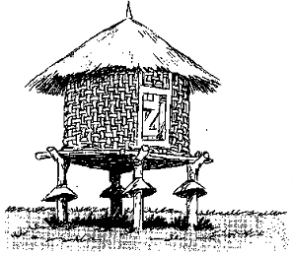

**A granary**

**Exercise**

1. Fill in the missing letters.

w _t se __son w_ ed gr _w f arm _r

1. Write the two seasons in a year.
2. What do farmers do in a wet season?
3. A----------------------------- is a young plant.
4. Where do farmers store their dried food?

**Dry/sunny season**

In this season there is little or no rainfall received at all for a long period of time.

**Activities done in a dry season**

Farmers prepare their land.

Farmers water their crops

Farmers harvest their crops

Farmers dry their seeds and store them in a granary

**Exercise**

1. Write any two activities done by farmers in a dry season.
2. In which season do farmers do the following activities
3. Watering plants…………………
4. Weeding crops………………….
5. Drying seeds……………………
6. Transplanting seedlings…………
7. Harvesting crops………………………….

**Garden tools**

**Uses of garden tools**

**Hoe –** for digging, for harvesting root crops

**Axe –** for cutting big trees.

**Rake –** for collecting rubbish.

**Knife -** for harvesting, for peeling

**Panga –** for cutting small trees

**Spade -** for turning manure

**Wheel barrow –** for carrying manure/for carrying seeds

**Slasher –** for slashing

**watering can –** for watering plants

**Sickle –** for harvesting crops like rice, millet, sorghum

**Trowel-**  for transplanting seedlings.

**Exercise**

1. Name these garden tools.

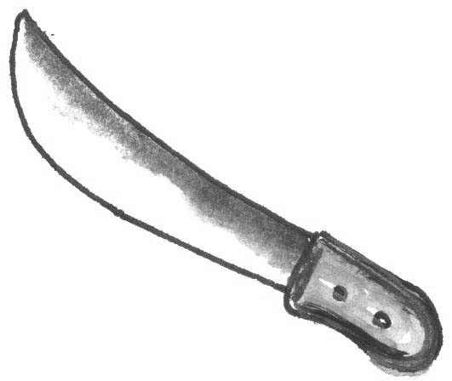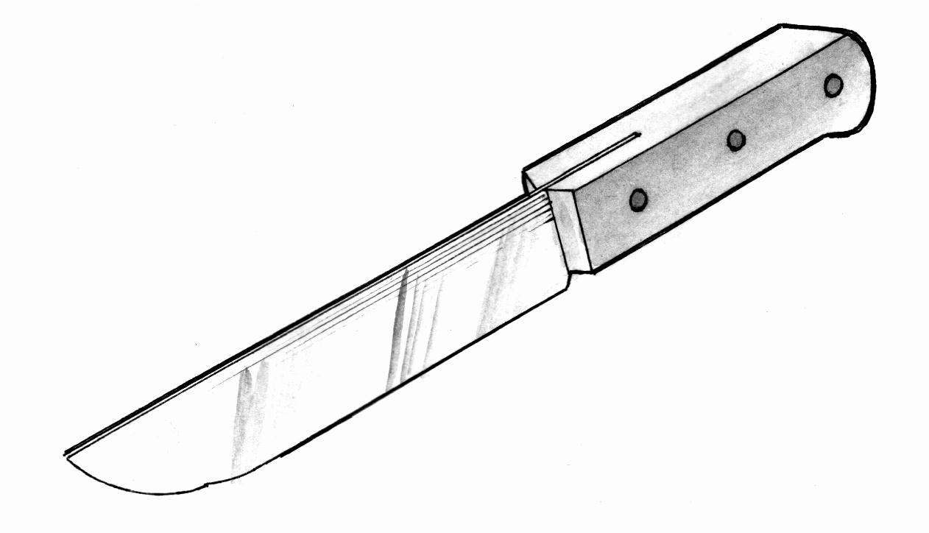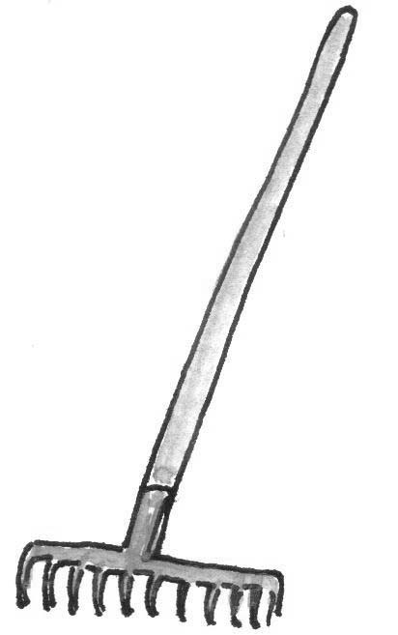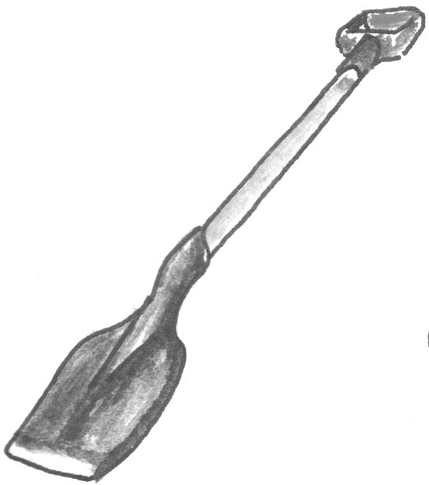

1. Match the garden tools to their uses

Slasher

Panga

Watering can

Hoe

For watering crops

For digging

For slashing

For cutting small trees.

**How to care for garden tools**

Keeping them in the dry place

Removing soil after use

Putting them in the store at night

Oiling them

**THEME 6: ACCIDENTS AND SAFETY**

**Accidents**

An accident is a sudden happening that causes harm to the body.

**Examples of accidents**

cuts falls burns bites poisoning stings

drowning shocks motor accidents chokes

**Exercise**

1. An __________________is a sudden happening that causes harm to the body.
2. Write down four accidents you know.
3. Draw these accidents

cuts motor accidents falls bites

**Places where accidents can happen**

home school on the road/way on water

in the space/ atmosphere neighbourhood

**Accidents at home and school**

burns, falls, cuts, poisoning, choking, shocks, bites, drowning, stings,

**Accidents on the way/road**

motor accident, drowning, bites, stings, falls

**Accidents in the neighbourhood**

Motor accidents

Drowning

Bites

Stings

Falls

Poisoning

Cuts

**Exercise**

1. Name three places where accidents can occur.
2. Name any two accidents that may occur in these places.
3. **Home :**
4. **School:**
5. **On the way:**
6. Draw and name any three accidents you know.

**Things that cause accidents**

pins motorcycles bicycles insects barbed wire

coins nails poison drugs hoe

broken glasses/bottles knives panga axe cars

razorblades needles fire thorns animals

hot things sharp stones electricity

**Exercise**

1. What do we call the sudden injury on the body?
2. Give any four things that cause accidents.
3. Draw and name four things that cause accidents.

**Causes of accidents**

Most common accidents are caused by the following

High speed

Bad roads

Untrained drivers

Drunken drivers

Over loading vehicles

Playing on roads

Climbing trees

Poor storage of medicine

Playing with sharp objects

Playing with fire

Playing with animals and insects. e.g. dogs and bees

**Exercise**

1. Give any two causes of accidents
2. At school

1. on the road (
2. at home

**Ways of avoiding accidents**

Never go swimming alone

Stay away from water logged places

Never play with sharp objects

Not playing with fire

Not playing on the road

Not playing with animals

Training drivers

Avoid playing with coins, keys

Not climbing trees

Not over loading cars.

Keeping medicine away from children

Avoid playing on electricity.

Not over speeding cars

Not over loading cars.

**Exercise**

1. Give any five ways of avoiding accidents

**Effects of accidents**

Lameness

Death

Blindness

Deafness

Sickness poverty

Destruction of things

Break up of family

**Exercise**

1. Give any three effects of accidents
2. Draw and name two effects of accidents

**First aid**

**First aid** is the first help given to an injured person

**Injury** – Is the damage caused to the body

We give first aid when one has got on injury either through accident or illness.

**First aider** – A person who gives first aid

**First aid kit/box** – Is a box used to keep materials for giving first aid.

**First aid box**

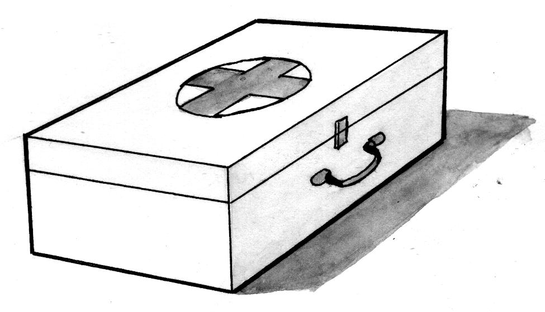

**Things found in a first aid box**

Cotton wool

Gloves

Safety pin

Plaster

Black stone

Pain killers

Spirit

Needle

Razor blade

Scissors

Clean water

bandage

thermometer

surgical blade

**Exercise**

1. ________________is the first help given to an injured person.
2. _________________is the box used to keep things used in giving first aid.
3. **Name this box**.



1. Draw and name four things found in the first aid box.

**Why do we give first aid?**

To save life

To reduce pain

To avoid more injuries

To stop bleeding

**Exercise:**

1.Why do we give first aid?

2. Name the person who gives first aid.

**THEME 8: FOOD AND NUTRITION**

**Food**

Food is something good to eat or drink

**Examples of food we eat**

Cassava

Maize

Bananas

Yams

Rice

Tomatoes

Sweet potatoes

Millet

Sorghum

Wheat

Fish

Eggs

Meat

Groundnuts cabbages

Cow peas

Simsim

Beans

Chicken

fruits

**Examples of fruits we eat.**

Oranges, mangoes, jackfruits, apples, passion fruits, guavas, pawpaw, avocados, water melon, pineapples, pears, grapes

**Exercise:**

1. What is food?
2. Name any four examples of food we eat.
3. Draw these fruits
4. orange
5. apple
6. mango

**Sources of food**

These are places where we get food.

Garden

Lake

River

Animals

Shops

Market

Supermarket

Farm

Swamp

The main source of food is the **garden.**

**Exercise:**

1. Mention any four sources of food.

2. What is the main source of food?

3. Draw these sources of food.

(a) Garden (b) lake (c) river

4.How is a garden important to people?

**Uses of food to our bodies**

Food keeps our bodies healthy

It gives us energy

It makes us to grow

**Why do we eat food?**

To be healthy

To kill hunger

To be happy

To grow

To get energy

**Exercise:**

1.How is food useful to our bodies?

2. Why do we eat food? (state three reasons)

**Classification of food (Classes of food)**

1. **Protein – (Body building foods)**

These foods provide material for building and repairing of bones. They are called **grow foods.**

**Examples of food rich in proteins**

Meat, fish, chicken, groundnuts, beans, soya beans, cheese, milk, eggs

1. **Carbohydrate – (Energy giving foods)**

These food help us to be strong

They are also known as **go food**

**Examples of foods rich in carbohydrates**

Sugar, honey, bread, millet, sorghum, wheat, cassava, butter, rice, maize, glucose, yams, bananas

1. **Vitamins – (Health giving foods)**

These foods help our bodies to fight against diseases

They are also known as **glow food**

They are commonly in **fruits** and **vegetables**

**Fruits vegetables**

apples - Nakati

avocado - Bugga

oranges - Sukuma

mango - tomatoes

yellow bananas - cabbages

pear -spinach

pineapples -egg plants

-cucumber

**Exercise**

1. Name four examples of foods rich in proteins.
2. Give three examples of foods rich in vitamins.
3. Mention four examples of foods rich in carbohydrates.
4. **Match correctly**

Proteins mangoes

Carbohydrates fish

Vitamins cassava

**Preserving food**

This is keeping food for a long time without goingbad.

**Ways of preserving food`**

By smoking

By salting

By roasting

By sun drying

By freezing

By tinning

By cooking it

**Ways of keeping food safe**

By covering it

By washing it

By cooking/steaming it

By storing it

By warming it

**Exercise**

1. How do we preserve food? (Give three ways)

By

By

1. How do we keep food safe? (Give two ways)
2. Draw and name two ways of keeping food safe.

**Importance of keeping food safe**

**Why do we keep our food safe?**

To avoid it from getting germs.

To avoid it from getting bad / spoilt

To avoid dust from getting on it.

To avoid diseases

.

**Exercise**

1. Why do we keep our food safe? (state four reasons)

**THEME 7: LIVING TOGETHER**

**Family**

A family is a group of people living together related by blood or marriage.

A family is started by two people. These are **husband** and **wife.**

**Types of families**

There are two types of families.

**Nuclear** and **extended**

**Nuclear family:** A nuclear family is a family where we find father, mother and their own children

**Members in a nuclear family**

Father

Mother

Children (brother, sister)

**Exercise**

1. Fill in the missing letters

f _mily n _cl _ ar h _sb _nd w _fe

m _th_r f _th _r s _ster

1. A _______________is a group of people living together related by blood or marriage.
2. Name the people who start a family.
3. 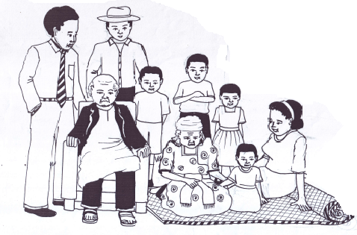Name the two types of families drawn.

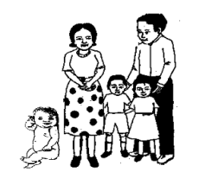………………… …………………..

1. Mention three people found in a nuclear family.

**Map of the members found in a nuclear family**

Nuclear family

**relatives**

**father**

**children**

**Extended family**

An **extended family** is a family where we find father, mother, children and other relatives.

**Examples of members in an extended family**

Mother, father, children, grandfather, grandmother, uncle, aunt, cousin, niece nephew

**Map of an extended family**

**father**

**relatives**

**children**

**mother**

**extended family**

**Examples of relatives**

grandmother

grandfather

cousin

nephew

niece

aunt

uncle

**Exercise**

1. A _____________is a group of people living together related by blood or marriage.
2. What do we call a family where we find father, mother, children and other relatives?
3. Draw and name any four members of an extended family.

**Family relationship (family tree)**

Mr. and Mrs. Wamala Mr. and Mrs. Male

Mr. Sempa Mrs. Sempa

Tom Tim Tina

**Exercise**

1. Who is the wife of Mr. Sempa?
2. Who are the children of Mr. and Mrs. Sempa.
3. What does Tom call Mrs. Wamala?
4. Who is the daughter of Mr. and Mrs. Male?
5. Who is the sister of Tom and Tim?
6. What is the relationship between Tom and Mr. Wamala.

**Roles of family members**

**Roles of parents in a family**

They pay school fees

They buy food

They cook food

They wash clothes

They pay house rent

They pay water bills

They pay electricity bills

They grow crops

They give us protection

They iron clothes

**NB.** A **father** heads a family.

**Exercise**

1. Give any two people who give us care in a family.
2. How are the following people useful in a family
3. Mother……………………………….
4. Father……………………………..
5. Who heads a family?

**Roles/duties of children in a family**

They wash utensils

They fetch water

They collect firewood

They clean the house

They wash clothes

They care for young ones

**Exercise**

1. How are children useful in the family? ( Give three ways)

2. Draw these activities children do at home.

(a) Fetching water

(b) Washing utensils

(c) Fetching firewood

**Family needs**

There are five basic needs of a family.

Food

Shelter

Water

Medical care

Clothing

**Other needs in a family**

Love

care

Money

Education

Security